**Lab report no 6**



**Fall 2021**

# Computer Architecture and organization Lab

**Submitted By**

**Names Registration No**

# Muhammad Ali 19pwcse1801

Section: **A**

**Date**: 26,1,2021

**Submitted to:**

**Dr Amaad khalil**

Department of Computer Systems Engineering

University of Engineering and Technology, Peshawar

**Task no 9 (even number): -**

.data

msg: .asciiz"Muhammad Ali, 19pwcse1801 \n finding even number between the range \n"

msg1: .asciiz "enter starting number of the range \n"

msg2: .asciiz "enter ending number of the range \n"

msg3: .asciiz "even numbers between the given range are \n"

space: .asciiz " "

.text

li $t7, 2

li $t6, 1

li $v0 ,4

la $a0, msg

syscall

li $v0 ,4

la $a0, msg1

syscall

li $v0, 5

syscall

move $t0, $v0 # starting range number

li $v0 ,4

la $a0, msg2

syscall

li $v0, 5

syscall # ending range number

move $t1, $v0

li $v0, 4

la $a0, msg3

syscall

addi $t2,$t0, 1

loop:

beq $t2, $t1, end

div $t2, $t7

mfhi $t4

beq $t4, $zero , even

addi $t2,$t2, 1

b loop

syscall

even:

li $v0, 1

move $a0, $t2

syscall

li $v0 ,4

la $a0, space

syscall

addi $t2,$t2, 1

b loop

end:

li $v0, 10

syscall

**Register: -**

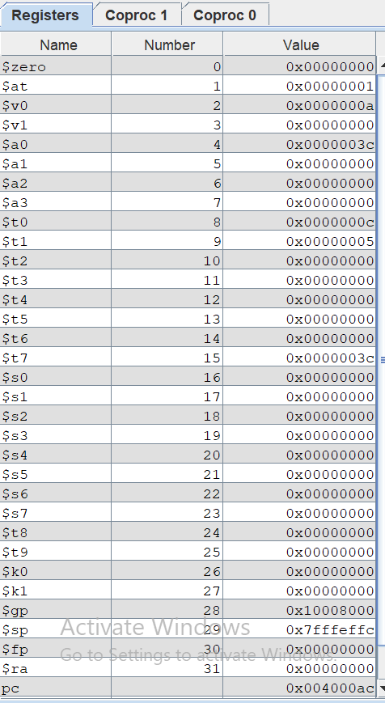

**Consul: -**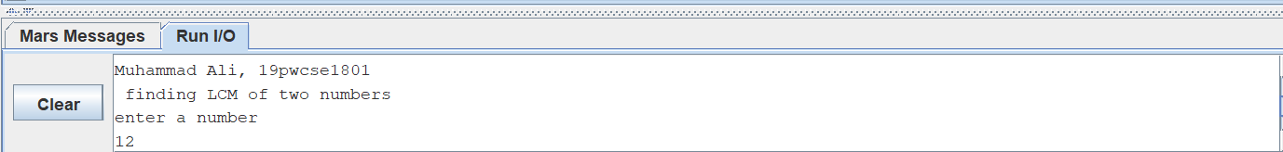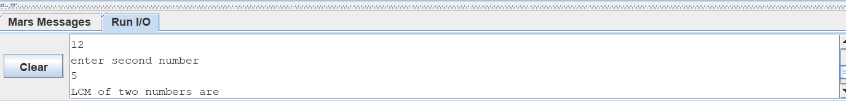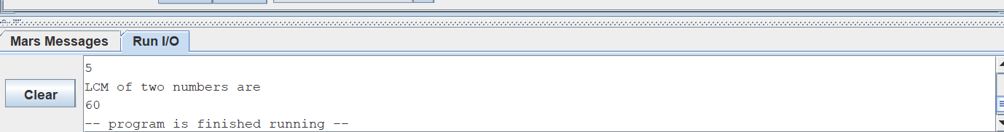

**Task no 10 (lcm): -**

.data

msg: .asciiz"Muhammad Ali, 19pwcse1801 \n finding LCM of two numbers \n"

msg1: .asciiz "enter a number \n"

msg2: .asciiz "enter second number \n"

msg3: .asciiz "LCM of two numbers are \n"

.text

li $v0 ,4

la $a0, msg

syscall

li $v0 ,4

la $a0, msg1

syscall

li $v0, 5

syscall

move $t0, $v0 # fisrt number

li $v0 ,4

la $a0, msg2

syscall

li $v0, 5

syscall # second number

move $t1, $v0

li $v0, 4

la $a0, msg3

syscall

bgt $t0, $t1, first_is_greater

move $t7, $t1

first_is_greater:

move $t7, $t0

loop:

div $t7, $t0

mfhi $t4

beq $t4, $zero , check_second

addi $t7,$t7, 1

b loop

check_second:

div $t7, $t1

mfhi $t4

beq $t4, $zero , LCM

addi $t7,$t7, 1

b loop

syscall

LCM:

li $v0, 1

move $a0, $t7

syscall

b end

end:

li $v0, 10

syscall

**Register: -**

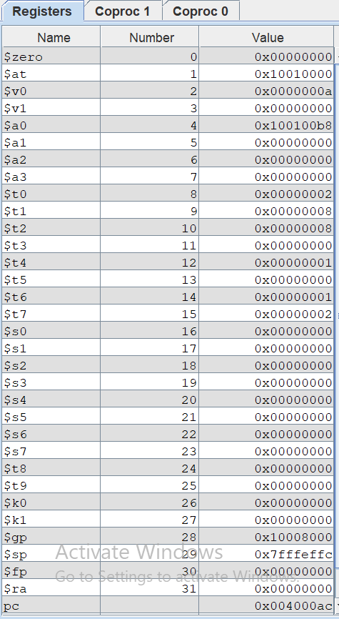

**Consul: -**

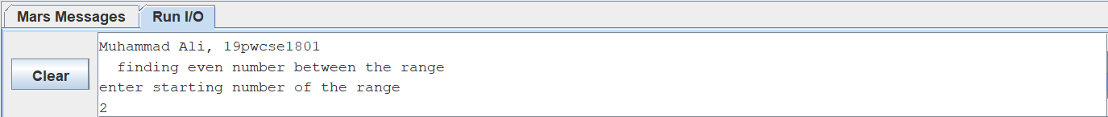

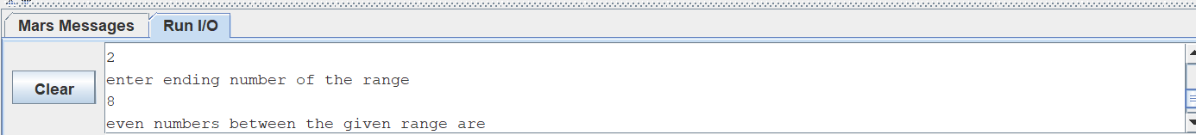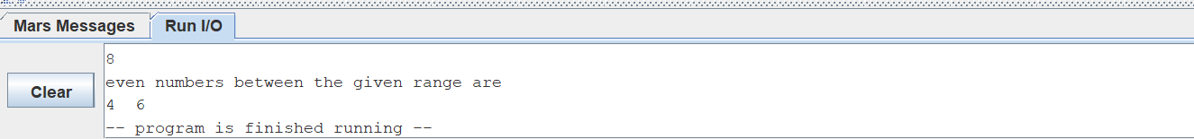

**Task no 11 (hcf): -**

.data

msg: .asciiz"Muhammad Ali, 19pwcse1801 \n finding LCM of two numbers \n"

msg1: .asciiz "enter a number \n"

msg2: .asciiz "enter second number \n"

msg3: .asciiz "HCF of two numbers is \n"

.text

li $v0 ,4

la $a0, msg

syscall

li $v0 ,4

la $a0, msg1

syscall

li $v0, 5

syscall

move $t0, $v0 # fisrt number

li $v0 ,4

la $a0, msg2

syscall

li $v0, 5

syscall # second number

move $t1, $v0

li $v0, 4

la $a0, msg3

syscall

blt $t0, $t1, first_is_smaller

move $t7, $t1

first_is_smaller:

move $t7, $t0

li $t6, 1 #iteration variable

li $t4, 1 #HCF variable

loop:

bgt $t6,$t7,HCF #$t6 is started with one and increment by 1 in each iteration

div $t0, $t6

mfhi $t4

beq $t4, $zero ,check_second

addi $t6,$t6, 1

b loop

syscall

check_second:

div $t1, $t6

mfhi $t4

beq $t4, $zero , increment

addi $t6,$t6, 1

b loop

increment:

move $4,$t6

addi $t6,$t6, 1

b loop

HCF:

li $v0, 1

move $a0, $t4

syscall

b end

end:

li $v0, 10

syscall

**Register: -**

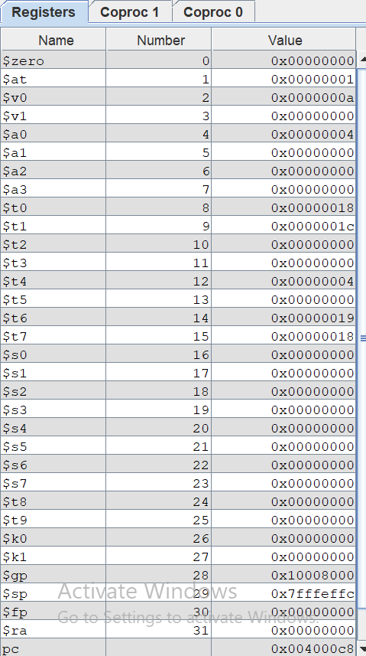

**Consul: -**

